
Bank of America

By: Jo Bailey

Date: March 22 2005

BOA Environmental performance
Please see the EIRIS report for Bank of America, which covers their environmental performance and related issues.

Environmental Strategy

Information from the BOA 2003 Environmental Update:

A team with representation from bank support units and lines of business, and external experts from environmental organizations met and assessed the bank's impact and influence on environmental issues. Using Six Sigma process improvement methodology the team developed a recommended prioritization of environmental impacts and issues for the Bank of America Environmental Commitment from 2003 through 2005. The priorities are:

- Energy and fossil fuel use
- Consumption and waste
- Climate change
- Biodiversity

The Environmental Advisory Group approved the assessment team's environmental issues prioritization. Using the priorities the following represents an overview of the bank's 2003 goals and accomplishments activities:

Energy/Fossil fuel
Reduce energy consumption by more than 3% annually through implementation of energy efficiency projects, enhanced building operations, development of energy conservation design and construction guidelines and by increasing associate education and awareness. Track and report results quarterly.

In 2003, the bank:

- Funded $7.9 million out of the Energy Conservation Capital Pool, which will result in an estimated (when completed and functional) 62 million kilowatt hours (KWH) electric reduction

- Reduced energy consumption in 2003 by 53.5 million KWH or 4.5%, which is equivalent to eliminating 87 million pounds of carbon dioxide greenhouse gas emissions. Reduction is estimated to save the bank $3 million annually.

- Implemented Energy Standards nationally.

- Developed the Portfolio Energy Score Card for the top 150 electric consuming properties.

Other energy efforts
The bank's new family of signs has been re-designed to take advantage of LED technology, which uses less energy and has lower maintenance costs. The bank is converting desktop monitors from cathode ray tube (CRT) to liquid crystal display (LCD) technology in banking centre environments to save energy. The bank contracted with Federal Express for its express mail delivery. Fed Ex announced that it plans to replace its fleet of 30,000 medium duty delivery vehicles with low emission hybrid electric power trucks over the next 10 years.

Consumption and waste
Paper purchases for 2003 increased 5.4% mainly due to increased marketing activity. Without marketing paper usage decreased 8%. Sheets per associate decreased 24%.

Recycled paper purchases
The percentage of paper purchased with recycled content decreased from 75% to 68% of all paper purchased in 2003 due to lower recycling content in marketing paper, which increased in volume.

Other efforts to reduce consumption
Converted all statement envelope paper (roughly 7,000 tons of consumption) from 20% pcc to 30% pcc. Under the PrintSmart program, began reengineering bank buildings to reduce print device deployment and upgrade to energy star rated devices. PrintSmart program reduces paper consumption, toner consumption and energy consumption. Continue to decrease paper consumption by digitizing document workflows.

Climate change
Bank of America approved a climate change position:

Climate change position summary
Recognizing that climate change and atmospheric pollution do indeed represent a risk to the ultimate stability and sustainability of our way of life and our business, Bank of America will take action including:

- Assessing our direct effect on green house gases
- Reducing our energy consumption
- Working with others to find solutions
- Assessing the risk to our business
- Informing our associates
- Reporting on goals, actions and progress

The bank's enterprise risk management executive is the executive champion for this effort and the Environmental Initiatives manager is project manager. In 2003, the bank:

- Shared its position internally with associates and externally through a letter to nonprofits, government agencies and businesses that have expressed an interest.
- Became the first financial services company to become a member of the EPA's Climate Leader Program.
- Began risk assessment by forming two teams, one to look at updating the bank's environmental guidelines and the second with key credit portfolio representation to look at the long view and make recommendations for future action. Both teams will complete work in 2004.
- Sponsored and participated in the Institutional Investors Summit on Climate Risk to be held in New York on November 21.
- Set up internal facility energy baseline.
- Responded to the Carbon Disclosure Project.
- Updated bank's Environmental Advisory Group at October meeting.

Biodiversity
Conservation Checks (cheques) sold in 2003 (cause-related marketing) totalled 188,450 resulting in a combined donation of $94,225 to the Nature Conservancy, Conservation International and Yosemite Fund. (see below for more on Conservation Checks).

Other biodiversity initiatives
- Sponsored the Land Trust Alliance annual conference
- Government Relations sponsored and attended the California legislative Smart Growth Caucus meeting
- Real Estate Banking Group and Environmental Initiatives continue to participate in Urban Land Institute district council or state smart growth efforts in California, Washington, Florida, Texas, South Carolina, Mid-Atlantic and Georgia.
- Participated in regional planning efforts in King County, Washington and the San Francisco Bay Region.
- Funded and participated in Smart Growth Funders Network's Real Estate Finance and Smart Growth project.
- Community Development Banking is an investor in the California Environmental Redevelopment Fund (CERF). CERF provides debt financing for the investigation and cleanup of contaminated properties ("brownfields") with viable redevelopment potential but that carry a higher risk profile due to the environmental conditions.

Customer, brand and communications
Through the Bank of America Foundation, 15 nonprofit organizations were funded with a total of $400,000 to support their efforts to protect and enhance the environment and to work with companies to find solutions to environmental issues. Bank environmental actions were mentioned or featured in ten unsolicited news or newsletter articles in 2003.

Due to the merger of Bank of America and FleetBoston, the bank did not publish a full 2003 environmental progress report. After the merger, the bank established a new environmental council and committed to report on the environmental progress for 2004 using the Global Reporting Initiative format (though there is no 2004 report on their website).

The website contains guidelines for lending where forests are an issue. See: http://www.bankofamerica.com/environment/index.cfm?template=env_workrel

All in all, the bank appear to be progressive from an environmental perspective. However, they do not appear to have specific targets for environmental management. This would give their work in this area more credibility.

Environmental information (external)

- Bank of America were admitted to the FRTSE4Good in September 2003.

- Bank of America adopted the Equator Principles (an industry approach for financial institutions in determining, assessing and managing environmental and social risk in project financing) in April 2004. However, according to Ethical Corporation the bank does not engage in project funding, which the principles are designed to address. According to Bank of America’s senior vice-president for environmental initiatives, Candace Skarlatos, while this is not an area in which the company has, or is planning, an exposure to, it was deemed important to be involved. “Bank of America has had an environmental programme since 1995, so we’ve been looking at these issues and how to address them.” “It was looking to some as if we were falling behind because we had not signed on to the Equator Principles, and this posed a problem because we do not do project finance. "Environmental groups were advocating that we signed, but many of our stakeholders are not aware that we don’t do project finance.” “So we decided to sign to help set benchmarks and standards in the area. If we ever do move into project finance, we will have a standard there.” Ms. Skarlatos also noted for instance that the bank was currently assessing risk profiles for climate change.

- To lessen its environmental impacts, Bank of America works to reduce paper use, recycle and support the market for recycled paper. In late 1999 the company launched its National Forms website, which contains close to 700 of the bank’s most commonly used forms. Bank of America continues to promote the reduced use of forms, and has implemented an online expense reimbursement system to eliminate the use of paper expense reports. From 2001-2002, the company reduced its use of paper forms by 25 percent.

- A June 2001 press release from Friends of the Earth reported that Bank of America was one of a number of major international financiers of APP, an Indonesian pulp and paper company said to be implicated in the destruction of large areas of Indonesian rainforest and the displacement of indigenous peoples.

- According to an article on the website Probe International on 25th July 2000, Bank of America was one of the financers of the controversial Three Gorges dam project in China. The article stated that concerns had been expressed over the flooding of large areas by the dam and the likely environmental impact of this. It was also stated that the project would black navigation of the Yangtze river and increase siltation at the port of Chongqing.

- Earth Matters reported in January 2001 that Bank of America had been named as a financial backer of the UK's first toll motorway. The construction of the Birmingham Northern Relief Road (BNRR) was scheduled for Spring 2001 and Friends of the Earth had argued that it was set to destroy 27 miles of greenbelt land and two sites described as being "of special scientific interest".

- The November 2004 issue of Multinational Monitor stated that Bank of America was one of a number of large corporations which had collectively spent more than $15 million campaigning for the 'gutting' of the State of California's unfair competition law. The effects of the campaign included the removal of a clause which had previously allowed corporations to be stopped from misleadingly advertising food to children, fraudulently advertising prescription drugs and selling medications containing dangerously high levels of lead.

Charitable Giving
The Bank of America Foundation contributed more than $108 million in cash to nonprofit organisations across the US in 2004. In 2005, they plan to begin an unprecedented $1.5 billion 10-year philanthropic goal. The foundation only gives in America, and focuses on community giving.

On March 17 2005, Bank of America commenced the second year of its ‘Neighborhood Excellence Initiative’, designating an additional $17 million to “recognize, nurture and reward organizations, local heroes and student leaders helping to rebuild and revitalize their communities in 38 of the bank’s major markets across the country”. The launch brings Bank of America’s total commitment under the Neighborhood Excellence Initiative to over $30 million.
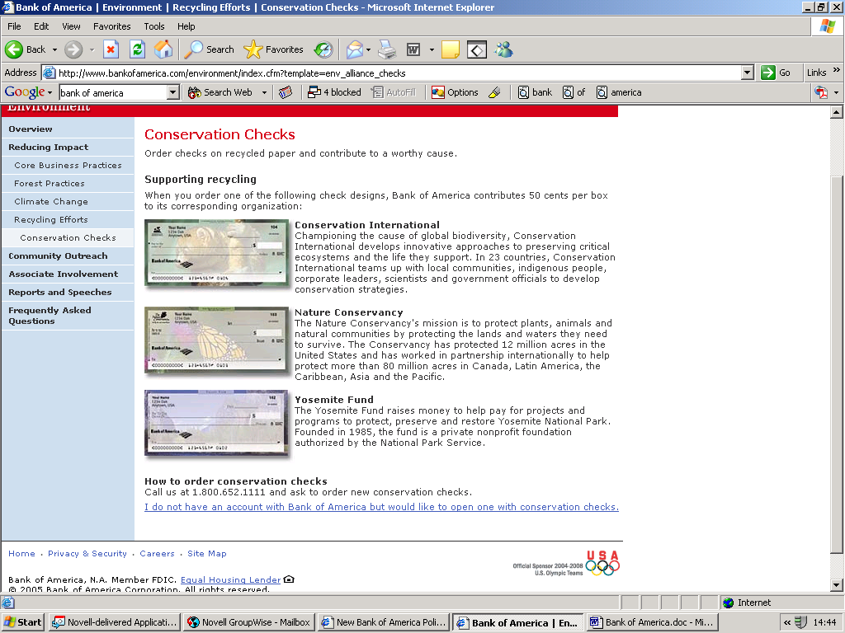
The Bank do offer a scheme whereby customers can chose cheques printed on recycled paper. A donation is also made to one of a range of charities as a result. See below:
Bank of America appears in no directories in the UK with regards to their giving. Their websites don’t contain anything about a UK presence.

news

Bank of America website, August 2, 2004: $1 Billion Project in Midtown Manhattan Will Result in the World's Most Environmentally Responsible High-Rise Office Building
NEW YORK - Bank of America and The Durst Organization today broke ground on the construction of the Bank of America Tower at One Bryant Park, a 945-foot-tall crystalline skyscraper that will rise in Midtown Manhattan. Located on the west side of Sixth Avenue, between 42nd and 43rd Street, the high-rise office tower is scheduled to open in 2008. Bank of America Tower will serve as the headquarters for Bank of America's operations in New York City, and house its global corporate and investment banking, wealth and investment management and consumer and commercial banking businesses. The bank will occupy roughly half of the 2.1 million square foot structure. The unique size of the building's footprint will enable Bank of America to operate six major trading floors there, ranging in size from 43,000 to 99,000 square feet. "The new Bank of America Tower will be situated prominently in the Manhattan skyline, and will represent our strong, long-term commitment to New York City and our customers around the world," said Kenneth D. Lewis, president and CEO of Bank of America. "This new building, in addition to our new Bank of America banking centers, underscores our plan to become an even bigger part of the New York community in the years ahead. We appreciate all that the State and the City of New York have done to make this possible." "I also give enormous credit to our partners in this major project, Douglas & Jody Durst, co-presidents of The Durst Organization," added Mr. Lewis. "Their shared vision for building a state-of-the-art high-rise office tower - and their shared commitment to developing a property that will meet our requirements for environmental stewardship - have made the Bank of America Tower at One Bryant Park a reality." "The new Tower - which will stand as one of the world's most environmentally responsible high-rise buildings - is a shining example of how you can create jobs while also protecting the environment," Governor Pataki said. "I want to commend the Bank of America and The Durst Organization for their commitment to New York. This project will not only help us reach our goal of creating one million jobs in New York by the end of the decade, it will bolster our efforts to provide the safest, cleanest environment possible for future generations of New Yorkers to enjoy."…Upon completion, Bank of America Tower will be the world's most environmentally responsible high-rise office building and the first to strive for the U.S. Green Building Council's Leadership in Energy & Environmental Design (LEED) Platinum designation. The project incorporates innovative, high-performance technologies to use dramatically less energy, consume less potable water and provide a healthy and productive indoor environment that prioritizes natural light and fresh air.

SocialFunds website, May 26, 2004: Environmentalist organization Rainforest Action Network helps usher Bank of America into the vanguard of US banks improving their environmental responsibility.
Bank of America (ticker: BAC) has surpassed Citigroup as the frontrunner on environmental responsibility and climate change risk mitigation in the US banking sector. Citigroup was the only US-based bank to sign onto the Equator Principles, a framework promoting environmental and social responsibility at financial institutions in their project financing, until Bank of America signed on last month. In January 2004, Citigroup and the Rainforest Action Network (RAN), a San Francisco-based environmentalist group, jointly announced Citigroup's new environmental initiatives that set the bar for US banks on environmental stewardship. Last week, Bank of America raised that bar by announcing with RAN even more progressive environmental policies and practices.

Bank of America’s commitments exceed those set by Citigroup in three distinct areas, according to Toben Dilworth, communications coordinator for RAN.

"BofA has agreed to articulate specific targets and timelines in order to reduce greenhouse gas emissions in both their direct operations and those that stem from their investments," Mr. Dilworth told SocialFunds.com. "BofA’s policy broadens the definition of 'no-go zones,' specifically prohibiting extractive operations in intact forests located in tropical, temperate, and boreal zones."

"BofA will not fund any projects where indigenous land claims are not settled," he added.

Bank of America commits to reduce by 7 percent its own direct emissions of greenhouse gases (GHG) such as carbon dioxide (CO2) by 2008. It bases this goal on best estimates of the Intergovernmental Panel of Climate Change (IPCC), which determines global scientific consensus on climate change. The bank also seeks to reduce by 7 percent its indirect GHG emissions, namely those the bank is exposed to through investment in its energy and utilities portfolio. Bank of America will commission a research report evaluating banking sector risk exposure through financing GHG emission intensive industries.

Recognizing that forests play a key role in recycling carbon globally, essentially breathing in the carbon emitted through human activity, Bank of America introduced a new forest practices policy. The policy bars the bank from financing resource extraction from old-growth tropical rainforests or logging of "intact" forests as defined in mapping by the World Resources Institute (WRI), an independent environmental think tank. Bank of America will provide financial assistance to WRI to continue mapping intact forests. The policy also prohibits financing companies that collude with in illegal logging operations

The forest practices policy covers not only environmental issues but also social concerns, specifically regarding indigenous populations.

"Bank of America respects the rights of indigenous communities whose livelihoods or cultural integrity could be adversely impacted," the policy states. "Due diligence procedures for projects in [sensitive] forests will weigh the impact of credit decisions on the indigenous peoples that could be affected."

"The bank will not finance the operations unless it is determined that indigenous peoples impacted by projects in these sensitive areas, whether directly or by induced impact, have the opportunity and, if needed, culturally appropriate representation, and have access to the information to engage in informed participation," the policy continues.

Bank of America's policies represent not only a high-water mark for other banks to strive for, but also a stepping stone floating above the water for the next bank to surpass with even more responsible environmental and social policies.

"Each policy will present itself as an opportunity to take another significant step toward beginning to reconcile ecology and economy within the financial sector," Mr. Dilworth said. "We recognize that currently, as much as the policies are progress, they are clearly not enough to confront the magnitude of the problems facing us--there are many areas where we will be continuing to press for significant changes.

"These include an immediate ban on coal projects, and establishing free and prior informed consent for indigenous communities in order to guarantee say in projects affecting their land and livelihoods," he continued.

RAN is in active dialogue with other US banks, including Bank One (ONE), Wells Fargo (WFC), Goldman Sachs (GS), Wachovia (WB), and US Bancorp (USB).

"We look forward to seeing some additional major policies as well as continuing to work toward implementation of existing policies," said Mr. Dilworth.

SocialFunds website, May 17, 2004, Bank of America Sets New Industry Best Practices for Climate Change and Forest Policies
Bank of America and Rainforest Action Network today announced that Bank of America will lead the financial services industry by setting new industry best practices for the environment. The bank will enhance its environmental programs with climate change and forest policies that take significant new steps in the reduction of greenhouse gas emissions, protection of intact forest ecosystems and transparent public reporting to all stakeholders.

"The health of our environment has a very real effect on the health of our local and regional economies, and therefore on the health of our company," said Ken Lewis, chief executive officer of Bank of America. "At Bank of America, we know we have an opportunity and responsibility as leaders to promote sustainable, environmentally sound economic growth in all our communities. In meeting this responsibility, we are committing to a higher standard of environmental awareness in our business and financing practices, and will encourage others in corporate America to do the same."

Today's announcement articulates unprecedented targets and timelines to reduce greenhouse gas emissions throughout Bank of America's chain of activities. Initial reduction goals are based on current best estimates of the Intergovernmental Panel on Climate Change (IPCC), 7 percent by 2008. Bank of America recognizes its responsibility to address climate change and the role of the service sector in promoting and implementing reductions of greenhouse gas emissions that extends beyond its own operations, including relationships with customers and suppliers.

The enhanced policy increases forest protection to encompass intact tropical, temperate and boreal forest ecosystems and includes a commitment by Bank of America to assist in funding the ongoing mapping of these regions for future protection. Bank of America will not provide funding for resource extraction from old-growth tropical rainforests, and lending proceeds will not go to logging operations in intact forests as defined by World Resources Institute mapping as it is developed. Provision of lending proceeds in all other old-growth forests will be limited to projects and operations that provide independent third party verification of sustainable forestry practices. Recognizing the connection between the health of our planet and our communities, Bank of America has pledged to deny financing for projects in these sensitive forests where indigenous land claims are not settled. To view Bank of America's new policies go to: www.bankofamerica.com/newsroom/presskits/view.cfm?page=climateandforests.

"Bank of America's new policies on forest protection, climate change and indigenous rights reflect the type of leadership we need from the global financial sector," said Michael Brune, executive director of Rainforest Action Network. "By embedding strong environmental principles into its policies and practices, Bank of America is helping the financial sector to live up to the ideals of a democratic economy. We welcome Bank of America into a growing list of companies working to ensure that the natural capital of our global environment and the integrity of local communities are preserved indefinitely."

In addition to policy enhancements, Bank of America will create an environmental council to ensure that the bank's environmental goals and objectives are met, tracked and reported. The council will be led by Eugene M. McQuade, president of Bank of America, and will include senior executives from various business lines and support functions. Bank of America will meet regularly with Rainforest Action Network and other stakeholders to implement this policy and report on its progress.

Bank of America has had a strong environmental program since 1992 and is a recognized leader among corporations with environmental policies. The bank was the first Fortune 500 financial institution to endorse both the Coalition for Environmentally Responsible Economies (CERES) principles and the United Nations Environment Program Finance Initiatives (UNEP FI).

Bank of America is one of the world's largest financial institutions, serving individual consumers, small businesses and large corporations with a full range of banking, investing, asset management and other financial and risk-management products and services. The company provides unmatched convenience in the United States, serving 33 million consumer relationships with 5,700 retail banking offices, more than 16,000 ATMs and award-winning online banking with more than ten million active users. Bank of America is rated the No. 1 Small Business Administration Lender in the United States by the SBA. The company serves clients in 150 countries and has relationships with 96 percent of the U.S. Fortune 500 companies and 82 percent of the Global Fortune 500. Bank of America Corporation stock (ticker: BAC) is listed on the New York Stock Exchange.

Rainforest Action Network is a San Francisco-based environmental organization that is part of an international movement of grassroots activists who campaign to transform the relationship between economy and ecology by introducing environmental ethics to corporate bottom lines. For more information, visit www.ran.org.

Ceres Newsletter March, 2005
At the World Economic Forum in Davos, Baxter International and Bank of America were named two of the most sustainable corporations in the world by the "Global 100," a new project by Canada-based corporate social responsibility group Corporate Knights and international investment research and advisory firm Innovest Strategic Value Advisors. Baxter and Bank of America were chosen from 2,000 of the world's largest companies because their strategic ability to manage social, environmental, and economic performance places them in the top five percent of their respective sectors. (source 10).

SOURCES
- http://www.bankofamerica.com/newsroom/press/press.cfm?PressID=press.20030917.01.htm&LOBID=10
- http://www.equator-principles.com/
- Corporate Critic database
- http://www.bsr.org/CSRResources/IssueBriefDetail.cfm?DocumentID=49808
- EIRIS
- http://csrwire.com/bsr/article.cgi/3639.html
- http://www.bankofamerica.com/environment/
- http://www.bankofamerica.com/newsroom/press/press.cfm?PressID=press.20040517.01.htm
- eFinancialNews.com, June 23, 2004
- http://www.ceres.org/newsroom/newsletters.htm#network

